Ordering SOP

External Supplier Orders
- Download the MVLS Orders Form Template (MVLS Order Request Template .xlsx)
- Fill in the form as per requirements (appendix 1)
- Send an e-mail to mvls-order-requests@glasgow.ac.uk
  - Subject ‘203 Order Request’
  - Attach the MVLS order form
  - Attach quote (if one is available)
- Update the Sofie Spatharis Order sheet
- NOTE: 1 Order form can be used to place multiple orders from a single supplier

Ordering From University of Glasgow Stores

Appendix

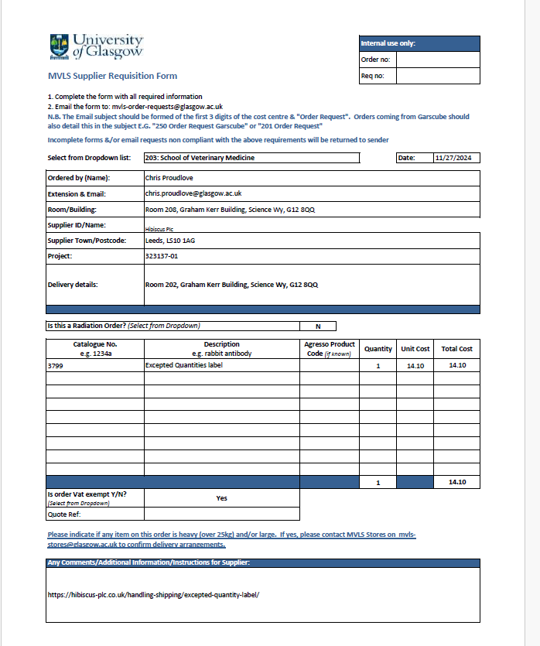
Fill in as appropriate
Additional Info to be added here, i.e. website link, selection details etc.
Input quote number if one if available
Select as appriopriate
Lab/Room for delivery (full address)
Project number for the order to be purchased off of
Input supplier details
Always ‘203’
Input date of order request

